**Project Title: - The Cake**

|  |  |
| --- | --- |
| Group Member 1 :- | **Muhammad Shazim** |
| Group Member 2:- | **Ahmed Hamza** |
| Group Member 3 :- | **Shams-ul-Hassan** |
| Group Member 4 :- | **Sarim Saleem** |

**languages**: **- Html, Css, Bootstrap, JavaScript, JQuery**

**Faculty: - Sir Zulfiqar ali**

**Link:-** **dcakeshop.gdn.aptech.hwssp.org**

Domain: [dcakeshop.gdn.aptech.hwssp.org](http://dcakeshop.gdn.aptech.hwssp.org/)

l

**Certificate of Completion**

**This is to certify that,**

Muhammad Shazim

Ahmed Hamza

Shams-ul-Hassan

Sarim Saleem

Has successfully Designed and Developed web on

The Cake Website

Domain: CPISM - [dcakeshop.gdn.aptech.hwssp.org](http://dcakeshop.gdn.aptech.hwssp.org/)

During e-project of CPISM (1st Semester)

**APTECH** Worldwide Computer Education,

Garden Center Karachi.

Issued By: 10-May-2021 Dated: 10-june-2021

ACKNOWLEDGEMENT

I Would Like To Acknowledge All Those Who Have Given Me Moral

Support And Helped In Making The Project A Success. I Wish To Express My Gratitude To E-Project Team At Head Office Who Guided And Helped Me .

Thanks To Our Teacher Sir Zulfiqar who Guided Us During The Project. Also, I Would Like To Express My Gratitude To All The Staff Members Of My Centre For Not Only Providing Me Opportunity To Work With Them On This Project, But Also For Their Support And Encouragement Throughout The Process.

I Also Express My Sincere Gratitude To E-Project Team From Aptech Head Office And My Project Guide At The Organization For Him Valuable Guidance And Support For Completion Of This Project. Final, I Would Like To Offer Many Thanks To All My Colleagues For Their Valuable Suggestions And Constructive Feedback.

PREFACE

First Of All, We Would Like To Thank ALLAH The Almighty, Who Gave Us Mind To Think And Heart To Feel Creativity & Creation Depends On Thinking.

Many People Contributed To This Project, And I Would Like To Thank All Of Them. Very Special Thanks To Our Teacher Sir Zulfiqar of APTECH For His Expert Advice And Brilliant Suggestion And Always Encourage Us To Do The Best. Indeed Class Fellows Are Very Important And We Would Like To Thank All Of Them For Their Kind Appreciation, Encouragement And Moral Support.

We Would Also Like To Express Our Deepest Gratitude To Our Parents Whose Well Wishes Enabled Us To Transform Our Dream Into A Reality .Finally Our Sincere Thanks To Our Teacher Sir Zulfiqarfor All Their Assistance In Making This Concept A Reality.

TABLE OF CONTENT

**Cover page 1**

**CERTIFICATE OF COMPLETION 2**

**ACKNOWLEDGEMENT 3**

**PREFACE 3**

**TABLE OF CONTENT** **4**

**PROJECT BRIEF****6**

**PROBLEM STATEMENT:-** **6**

**REQUIREMENT SPECIFICATION:-****6**

**PROJECT DESIGN** **7**

**SCREEN SHOT’S 8-69**

Project Brief

**Objective: -**

The Objective of this program is to give a sample project to work on real life projects. These applications help you build a larger more robust application.

The objective is not to teach you JavaScript/Dreamweaver but to provide you with a real life scenario and help you create basic applications using the tools.

You can revise the chapters before you start with the project.

This project is meant for students who have completed the module of ***HTML5***. These programs should be done in the Lab sessions with assistance of the faculty if required.

It is very essential that a student has a clear understanding of the subject. Students should go through the project and solve the assignments as per requirements given.

Kindly get back to eProjects Team in case of any doubts regarding the application or its objectives.

**Problem Statement**

**Requirement Specification:**

To create an informative, interactive and business website for Cake manufacturers. The brand name is “The Cake” and the shop is located all over the country. The website has to be informative enough for the end users / viewers to know brief of the various products and its prices and the availability.

You are supposed to create a website for them with the below mentioned requirement specifications.

The website is to be developed for the Windows Platform using HTML5, JavaScript and Geolocation. The site should work well in all leading browsers including Chrome, IE, Firefox etc.

The website should cover the following links / pages:

1. **Home page:** The page should be designed with a banner at the top of the page. The home page should cover a brief description of the entire website / presentation as well as a brief history of cake.
2. **About us:** divide the page into three sections vertically. Provide the foundation, mission and vision on these sections.
3. **All products:** the product page should be designed with all the products / thumbnails along with brief details of the individual products, such as
   1. item code
   2. Price
   3. Egg less/with Egg
   4. order button
4. On click on the order button a purchase form page should appear on a new browser window. The purchase form page should have all the form fields to capture the entire transaction and the users' details like
   1. Name
   2. Address
   3. Contact number
   4. Item code
   5. Quantity
   6. Delivery address
   7. Delivery Date
5. On click on the zoom button an enlarged image of the same product should appear on a new browser window.
6. **Products by event:** provide a categorized sub-navigation on this page such as
   1. Birthday
   2. Anniversary
   3. Engagement
   4. Marriage and so on.

Each and every sub-navigational button should be linked to an individual page. All the individual page should be designed with selected / categorized thumbnails along with brief details of the individual products, such as item code, price, zoom and order button.

1. On click on the order button a purchase form page should appear on a new browser window. The purchase form page should have all the form fields to capture the entire transaction and the users’ details.
   1. Name
   2. Address
   3. Contact number
   4. Item code
   5. Quantity
   6. Delivery address
   7. Delivery Date
2. On click on the zoom button an enlarged image of the same product should appear on a new browser window.
3. **Site Map:** The site map page should contain the entire navigational structure / diagram in a visual form and all the links (page names) of the diagram should be programmed for hyperlink to the respective pages.
4. About us, Contact Us, Disclaimer must be included. “Contact Us” page should have the Address of the Company and the mail address which when clicked will invoke the local mail client from where they can send an email. Address of the Company should be displayed using GeoLocation API (eg. GoogleMaps)
5. Creating an account facility can also be added.

Dummy procedure for buying to be added.

Project UI: -

**Home Page: -**

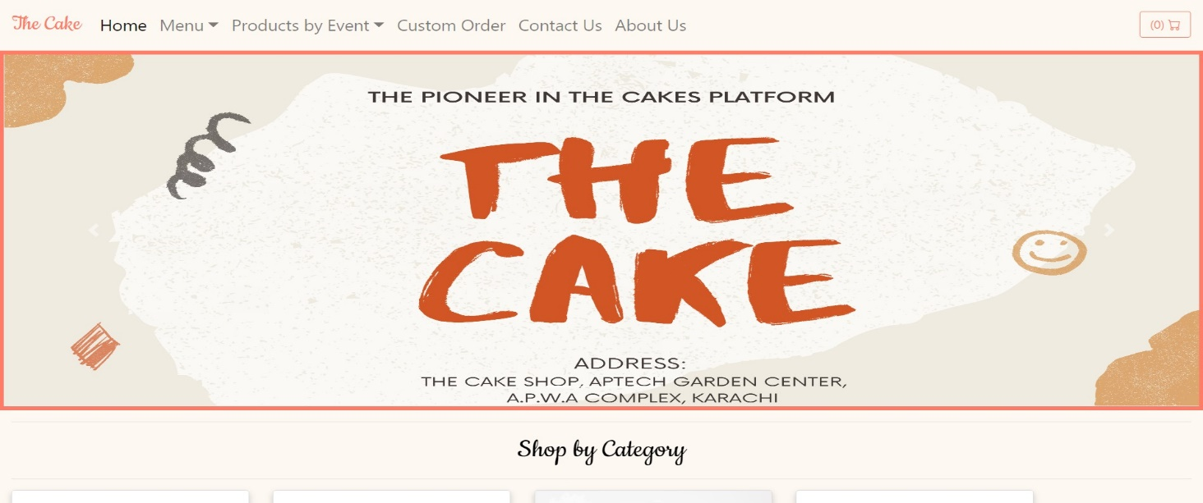

Project UI: -

**About us:-**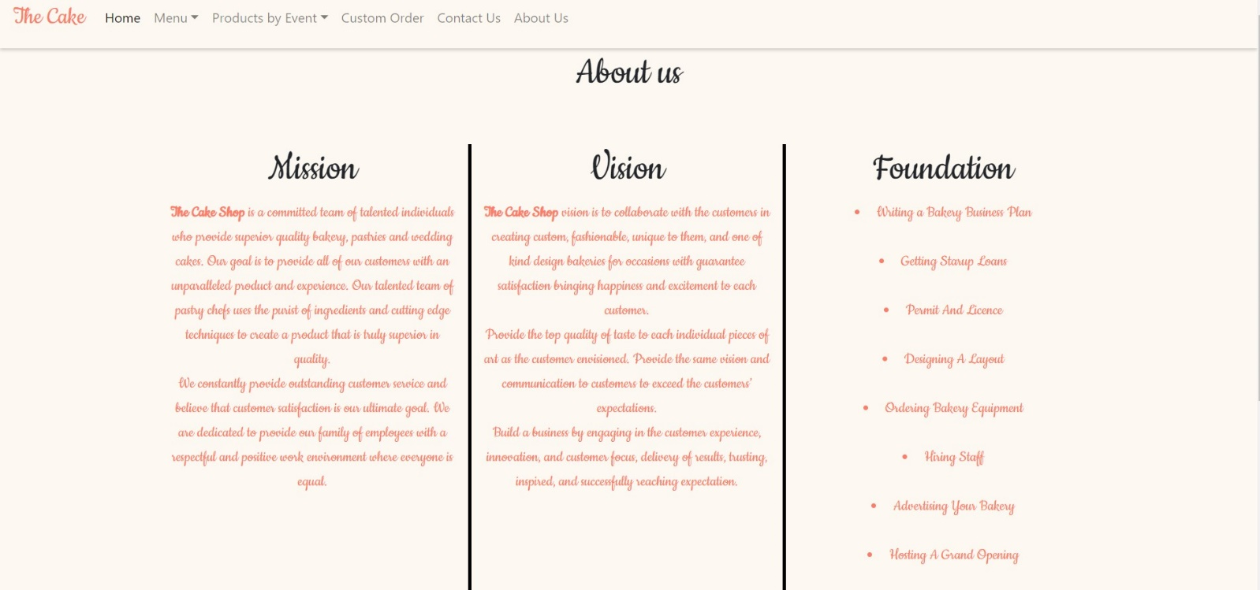

Project UI: -

**Contact us:-**

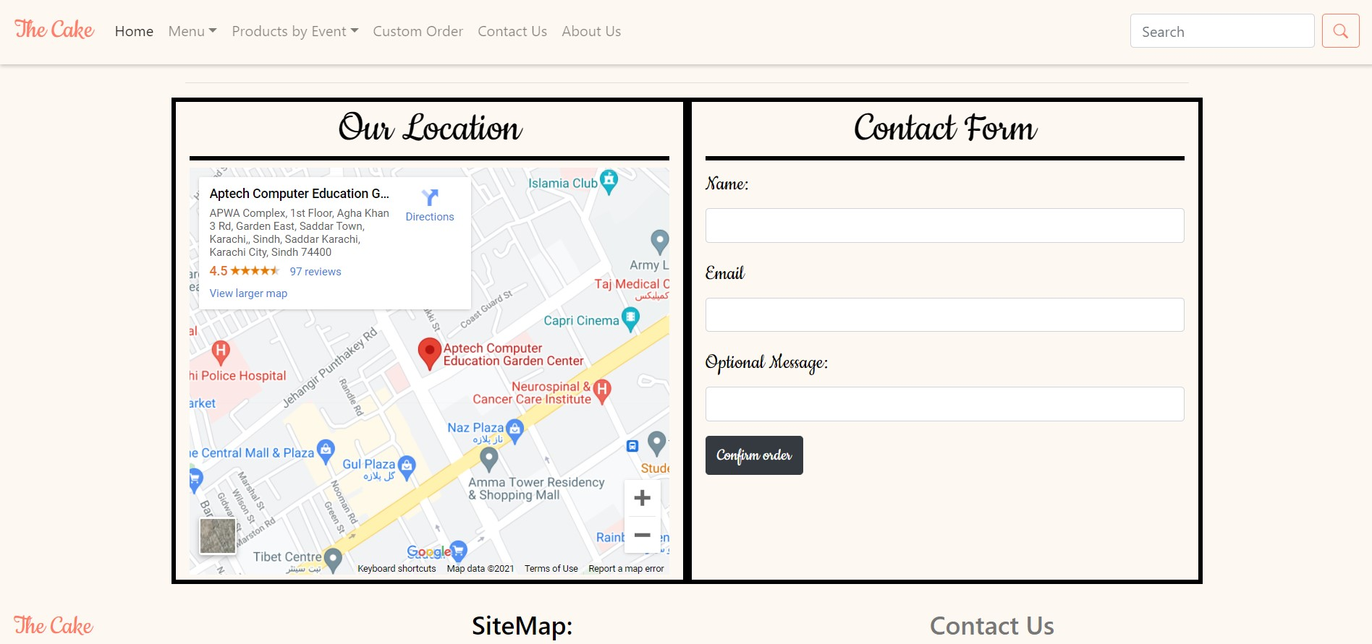

--The End--